# Deployment on Azure PaaS

## Deployment of Backend using Visual Studio:

Step 1 : Go to your project and click on Publish 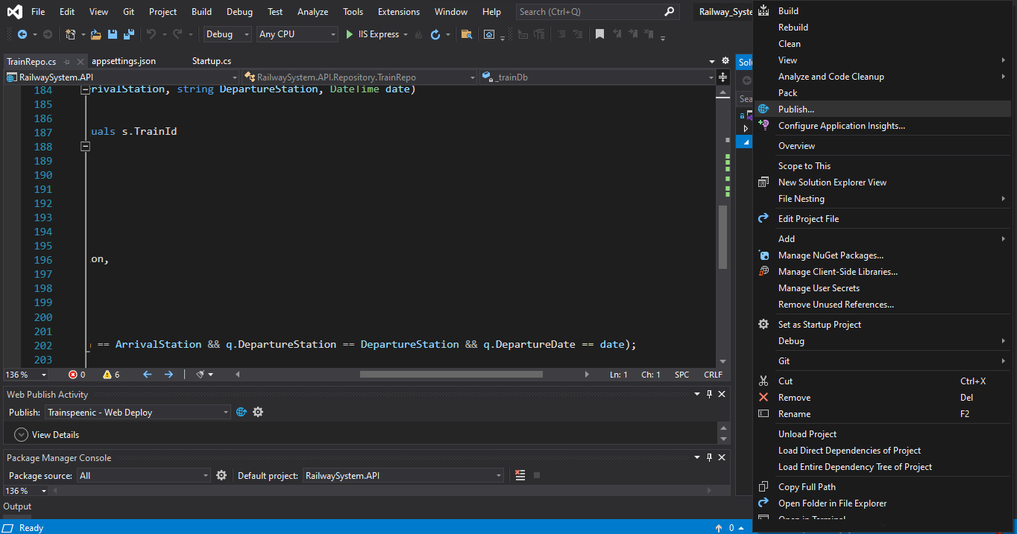

Step 2: Select azure and click on next.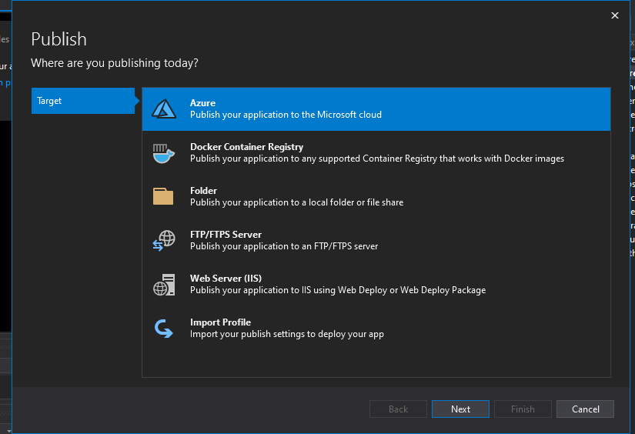

Step 3: Select your desired host application (I used Azure App Service). And click on next.

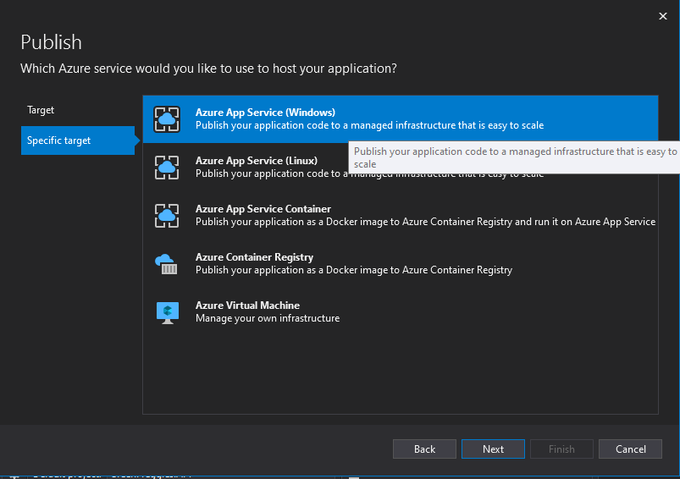

Step 4: Select your Subscription type and then click on the add button

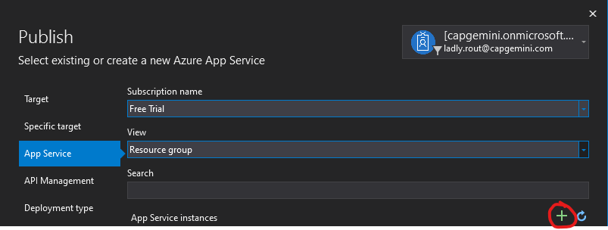

Step 5: You can rename your resource group and name if you’d like, Select your subscription name. And select your desired hosting plan by clicking on new near Hosting Plan.

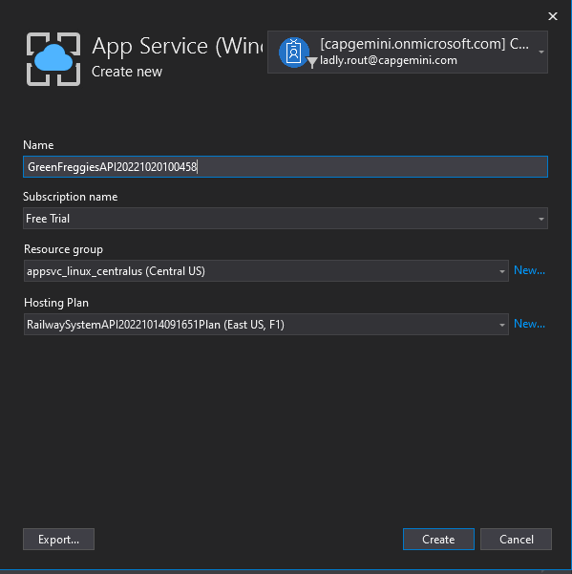

Step 6: Select the Location and Size and click ok.

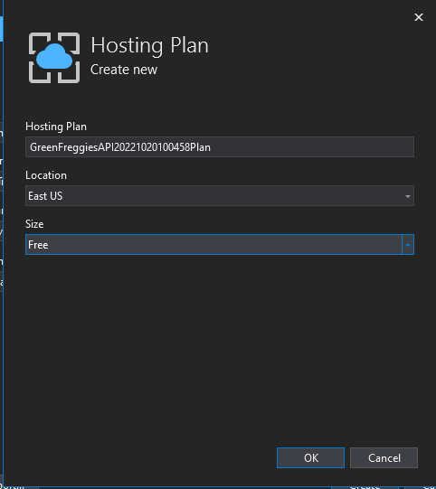

Step 7: Click on Create

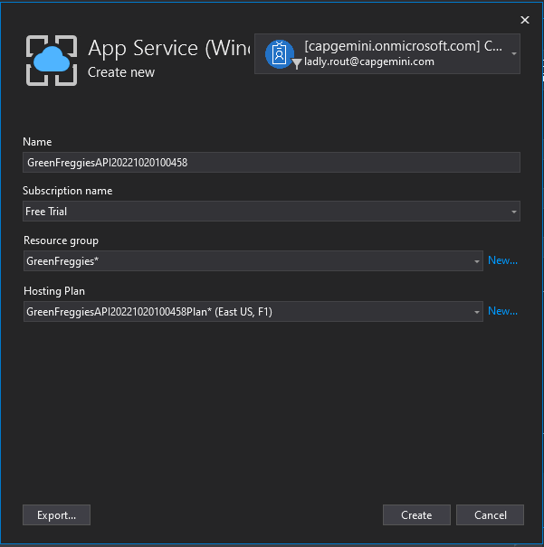

Step 8: Now that your app service instance is created, you can click on next.

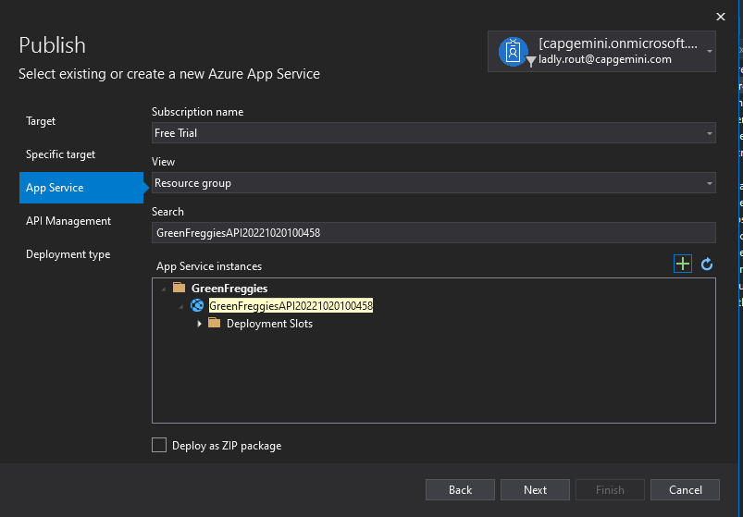

Step 9: You can go ahead and skip this step. And click on finish.

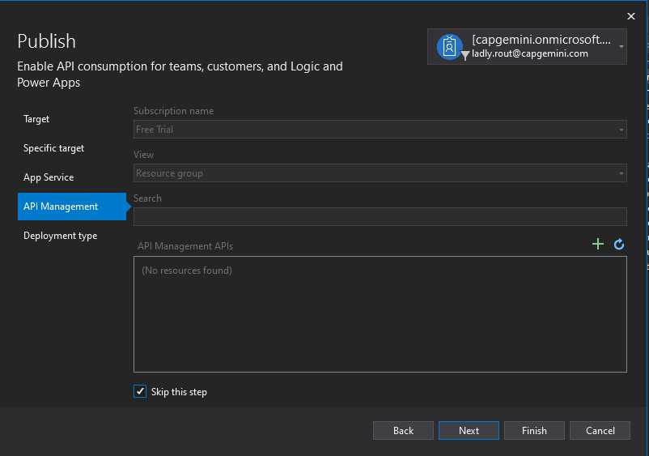

Step 10: Scroll down and Configure SQL Server Database

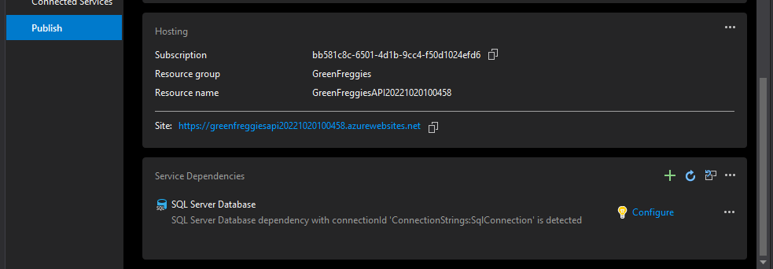

Step 11: Select your desired Database (I’ve used Azure SQL Database).

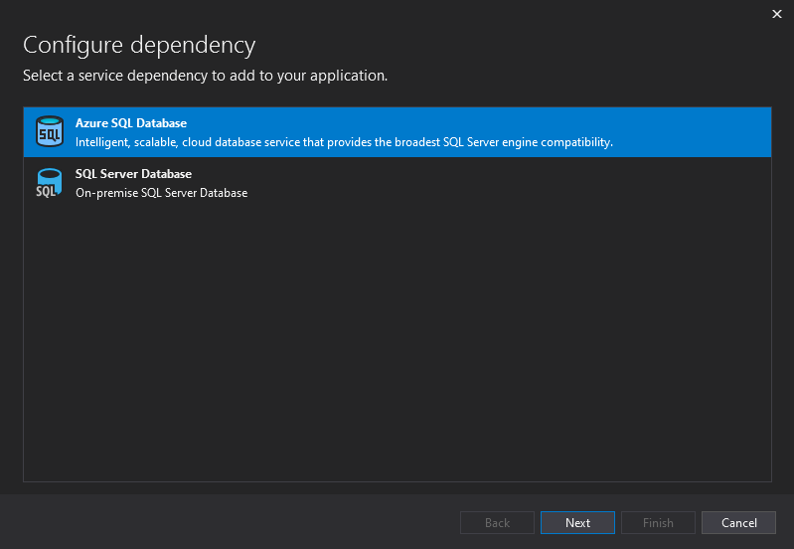

Step 12: Select your Subscription name. Click on the plus to select the SQL databases.

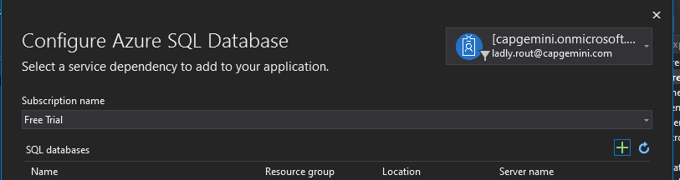

Step 13: Select new to select your database server

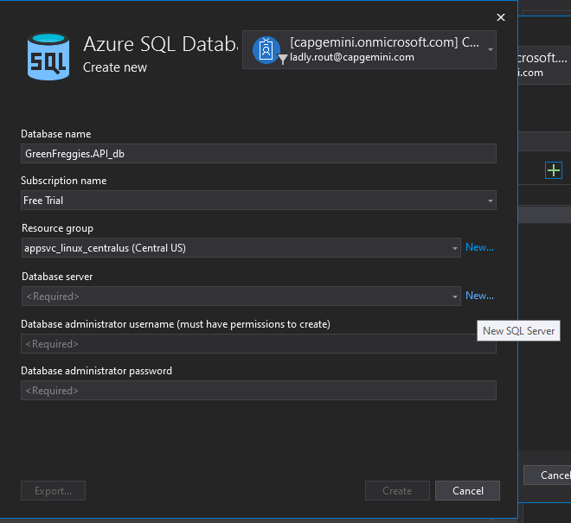

Step 14: Write a database server name, Administrator name, Password.

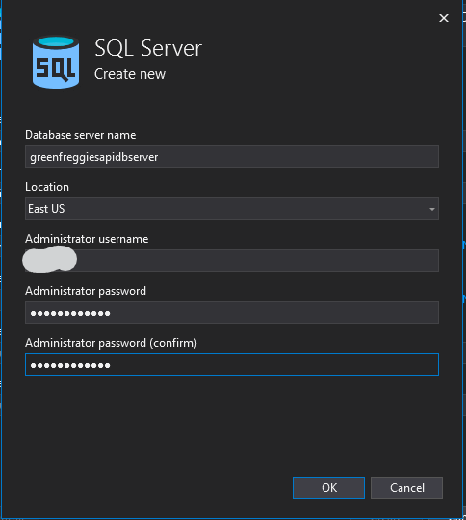

Step 15: Click on create, It’ll take a few minutes.

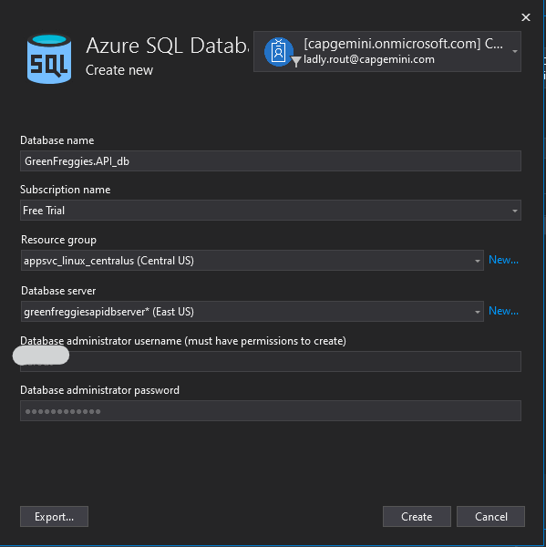

Step 16: Click on next.

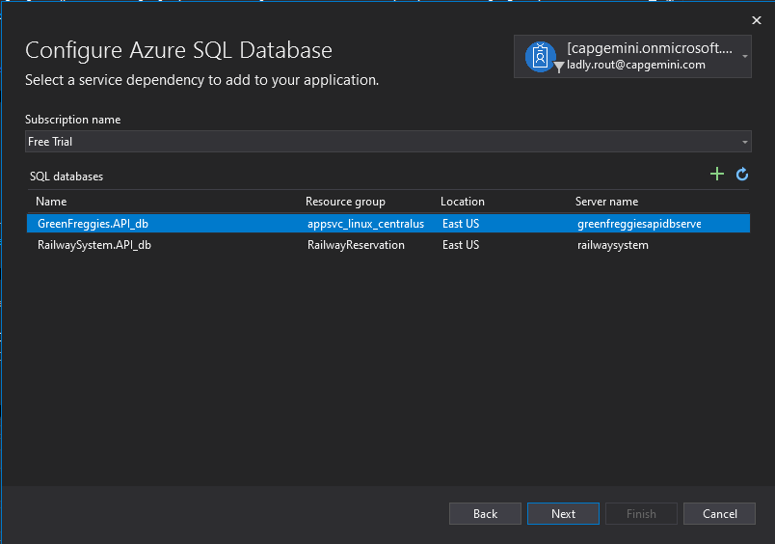

Step 17: Write your username and password. Click on next.

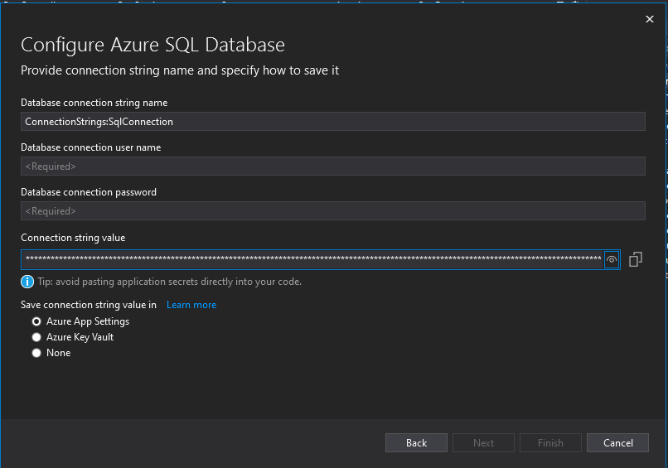

Step 18: Click on Finish.

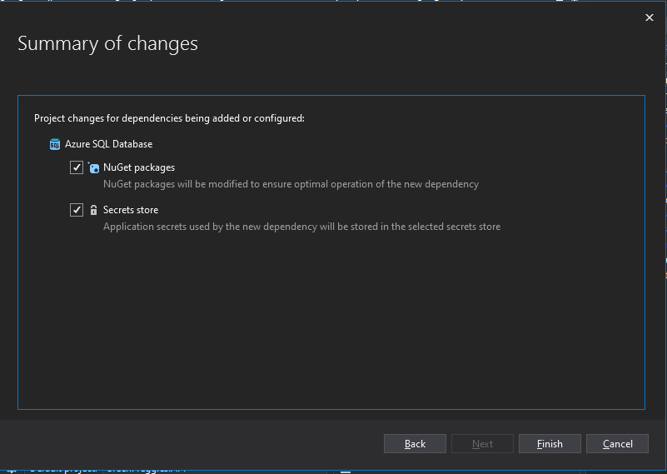

Step 19 : Click on More-Options.

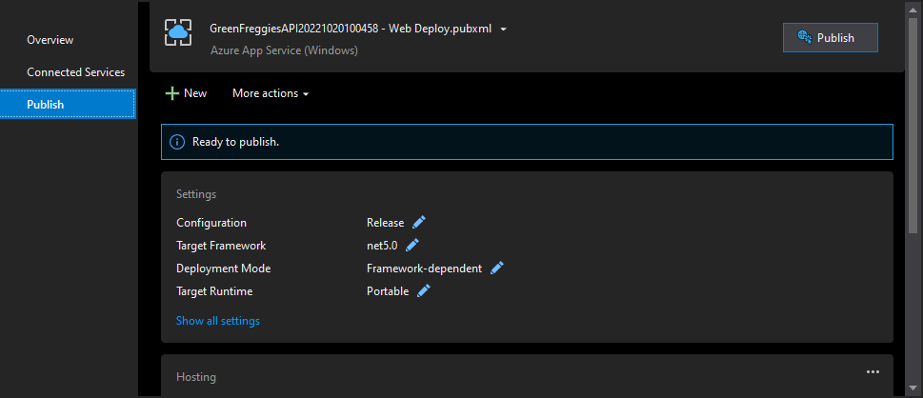

Step 20: Click on edit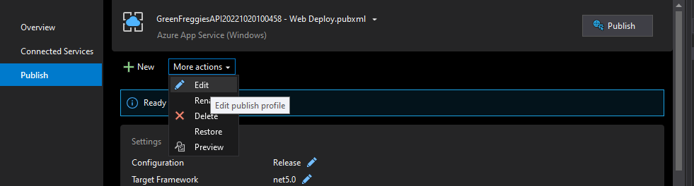

Step 21: Select the database.

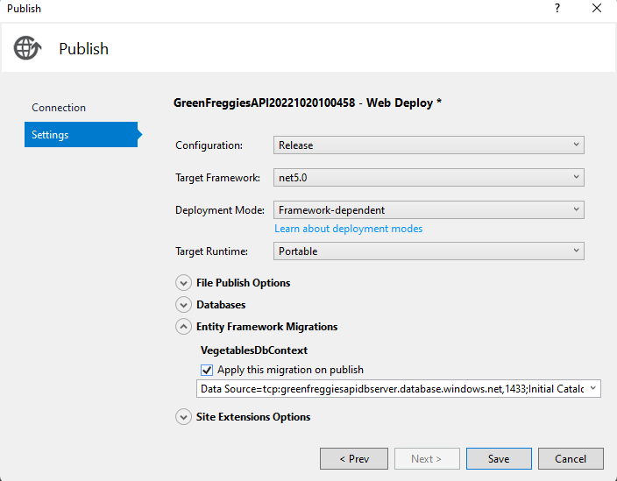

Step 22: Click on Publish.  
